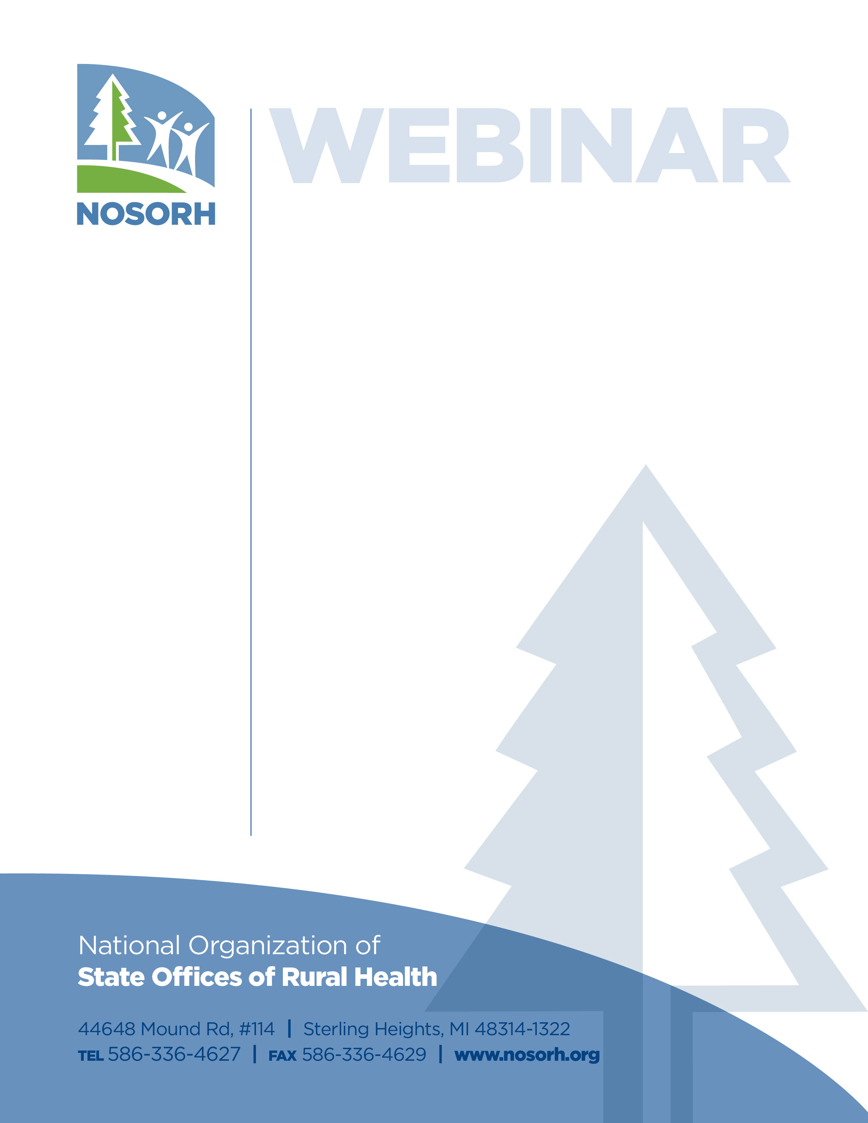

Agricultural Safety for Rural Workers: Resources for SORHs

Rural agricultural workers are an underserved population and are subject to a unique range of health risks including respiratory hazards, exposure to Zika and injuries. This webinar will provide information and resources to meeting the needs of rural agricultural workers. At the end of the webinar participants will:

1.       Understand the differences in occupational exposure to vapor-gas, dust, and fumes between rural and urban workers.

2.       Identify resources and data/trends/safety precautions regarding the Zika virus; and

3.       Access educational resources for nurses who care for agricultural workers.

Presenters:

Natalie Roy, MPH Brent Doney, MS, MPH, PhD

Executive Director Certified Industrial Hygienist

AgriSafe Network Respiratory Health Division

NIOSH, CDC

Paul Henneberger, MPH, ScD Allison Hutchings, MPH

Senior Science Advisor, Public Health Analyst

Respiratory Health Division Federal Office of Rural Health Policy

NIOSH, CDC HRSA

HOW TO REGISTER:

1. Go to: [Click here](https://nosorh.webex.com/nosorh/onstage/g.php?MTID=eda1be38312a472e504c96fb3e3718bf8)
2. Click **Register**
3. On the registration form, enter your information and then click **Submit**.

Date:   Monday, April 30, 2018  
Time:   3:00 – 4:00 pm EST  
Intended Audience: State Offices of Rural Health

For additional information, contact:

Chris Salyers

(888) 391-7258 x 106

Chris.salyers@nosorh.org

Funding for this conference was possible in part by Cooperative Agreement #U14RH19776 from the Federal Office of Rural Health Policy.

The view expressed in written conference materials or publications and by speakers and moderators do not necessarily reflect the official policies of the Department of Health and Human Services; nor does mention of trade names, commercial practices, or organizations imply endorsement by the US Government.